**Self-Driving Car**

**Problem Definition:**

In order to increase roadway safety autonomous vehicles are under development and are the focus of many research projects. The Rochester Institute of Technology wishes to have a reentry point to the field of autonomous vehicle research and currently does not have a vehicle to use as a starting point. To facilitate RIT’s goal a remote control golf cart was determined to be the first stepping stone. The scope of this project includes converting a golf cart to a remote control vehicle. The safety of the vehicle’s passengers and bystanders is of the utmost concern. Therefore the vehicle is required to be low speed and contain the ability for passengers to take control.

**Scope:**

The entire project is divide in to two parts

**1.To run the chatbot car on the defined track using opencv.**

**2. The second part consist of the image processing in which the decision are made based on the image fed to the system.**

**a) turn left and right on the defined path**

**b) Traffic sign detection and based on the sign ,appropriate decision is put into action**

**c) Stop or Change the lane when obstacle is detected**

**Abstract:**

The evolution of Artificial Intelligence has served as the catalyst in the field of technology. We can now develop things which was once just an imagination. One of such creation is the birth of self-driving car. Days have come where one can do their work or even sleep in the car and without even touching the steering wheel, accelerator you will still be able to reach your target destination safely. This paper proposes a working model of self-driving car which is capable of driving from one location to the other or to say on different types of tracks such as curved tracks, straight tracks and straight followed by curved tracks. A camera module is mounted over the top of the car along with Raspberry Pi sends the images from real world to the Convolutional Neural Network which then predicts one of the following directions. i.e. right, left, forward or stop which is then followed by sending a signal from the Arduino to the controller of the remote-controlled car and as a result of it the car moves in the desired direction without any human intervention.

**Introduction:**

Globally speaking, nearly 1.3 million people die in road crashes each year, on average 3,287 deaths a day .And talking about India the number of people who were killed in a road accidents in 2013 alone were 1, 37,000 .Speeding, talking over phone, drunk driving and breaking traffic rules are the root causes behind these accidents and the statistics are rising day by day which is now becoming a major concern. No matter how hard we try to create awareness regarding traffic rules and safety that has to be followed while driving, accidents are still occurring and aren’t showing a sign to stop. Though human errors can never be eliminated, but accidents can definitely be stopped. And in this case technology has surely come to our rescue. Starting from the very early radar-based collision detection to present day’s technology, the advancement and improvement in this technology had seen an exponential growth in recent years. Self-driving cars is the one of the most discussed technology of current scenario. What was once imagined is a reality now. The definition Self-driving cars is a car which promises to take the traveller to their destination with minimal human control while taking safety as its first priority. Many companies throughout the world are making a serious and continuous efforts to make driving a safe and risk-free process and have started building prototypes for the same. Amongst these companies are Google, Tesla Mercedes and many more who have built a successful and functioning prototype and are

planning to release a model in the upcoming years.

Self-driving cars are expected to have faster reflexes than humans, make more reliable judgments, thus avoiding mere faults which causes accidents at the first place. Apart from saving precious lives, other advantages these technology gives are better traffic flow regulation because unlike humans these

cars ride with proper traffic rules, making rides smooth and congestion free. Self-driving cars can also help in tackling parking space issues by allowing to create a taxi/pooling service for the unused cars and by unused car we mean to say the car that is either staying for few hours while the owner is at work or the car that is in the garage while the owner is out for a vacation. Thus, we could make better use of land instead of using it for parking space. The basic model of any Autopilot system involves radar, a front-facing camera, a digitally-controlled digital braking system, and long-range ultrasonic sensors located around the car. Radars enables the

detection of vehicles and other moving objects around the car, front facing camera helps to detect and recognize objects like cars, trees, driving lane, humans, traffic signals and other important data. All these information are taken in real-time environment and are fused into a learning network which then predicts the car’s response accordingly.

**Objectives:**

With autonomous vehicles and [connected cars​](https://www.gemalto.com/automotive/connect-cars) already starting to hit the roads of cities across the globe, the potential benefits and challenges of this mobility revolution are being scrutinized in increasing detail. [Research from Ohio University​](http://onlinemasters.ohio.edu/the-future-of-driving/) has highlighted just some of the potential ways that driverless cars could improve our lives – whether it's by being more environmentally friendly, improving our cities or being much safer for drivers and pedestrians alike.

Here are just a few of the ways a driverless future might benefit us all…

**Green machines**

Autonomous vehicles are, to all intents and purposes, software on wheels. The technology involved in a driverless car of the future will be such that each vehicle can be optimized to ensure fuel consumption is as efficient as possible. So much so that new-age cars are expected to help reduce emissions by 60%.

**Safer streets**

With the potential for human error removed, self-driving cars will reduce instances of accidents caused by driver error, drunk driving or distracted drivers.

Once driverless cars become commonplace on our streets, it is expected that accidents are likely to fall by a whopping 90%.

**Time is money**

Average commuter times in metropolitan areas in the US are currently estimated to be around 27 minutes each way.

With humans no longer involved in driving, commuters are likely to save up to an hour every day – time that will undoubtedly have many spin-off benefits from wellbeing to boosting the economy.

**Tailoring traffic**

Every year, people living in American urban areas spend almost 7 billion hours in traffic, waste 3.1 billion gallons of fuel and lose around $160 billion due to traffic congestion.

With driverless cars able to access up-to-the-minute data to help monitor traffic, as well as digital maps and other tools, they will be able to determine the fastest, most efficient route possible. All of this will result in less traffic, less congestion and less time and fuel waste.

**Space savers**

Driverless cars will play a key role in the future of smart cities, and they will even impact the way city infrastructure is designed and built. Today, parking lots require cars to be parked with enough space left between each vehicle for the driver to get out after they have parked their vehicle. Self-driving cars will negate the need for this by parking themselves, meaning it will be possible for cars to be stacked more closely alongside each other.

It is estimated that driverless cars can be parked with 15% less space – resulting in significant space-saving for urban areas across the globe.​

**Literature Review:**

According to the National Highway Traffic Safety Administration (NHTSA), in 2016, the U.S. had 6.3MM car crashes, 2.5MM injuries from those crashes, and 37,461 fatalities from those crashes. Areas like avoiding the tens of thousands of fatalities every year are priceless, but here I will try to quantify the problems driverless cars solve. Below is a summary of areas I could quantify where we could have real annual savings in the U.S. alone:

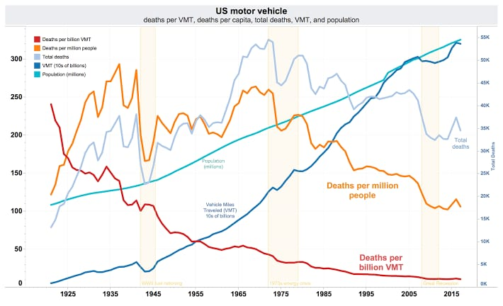

**Technology stack:**

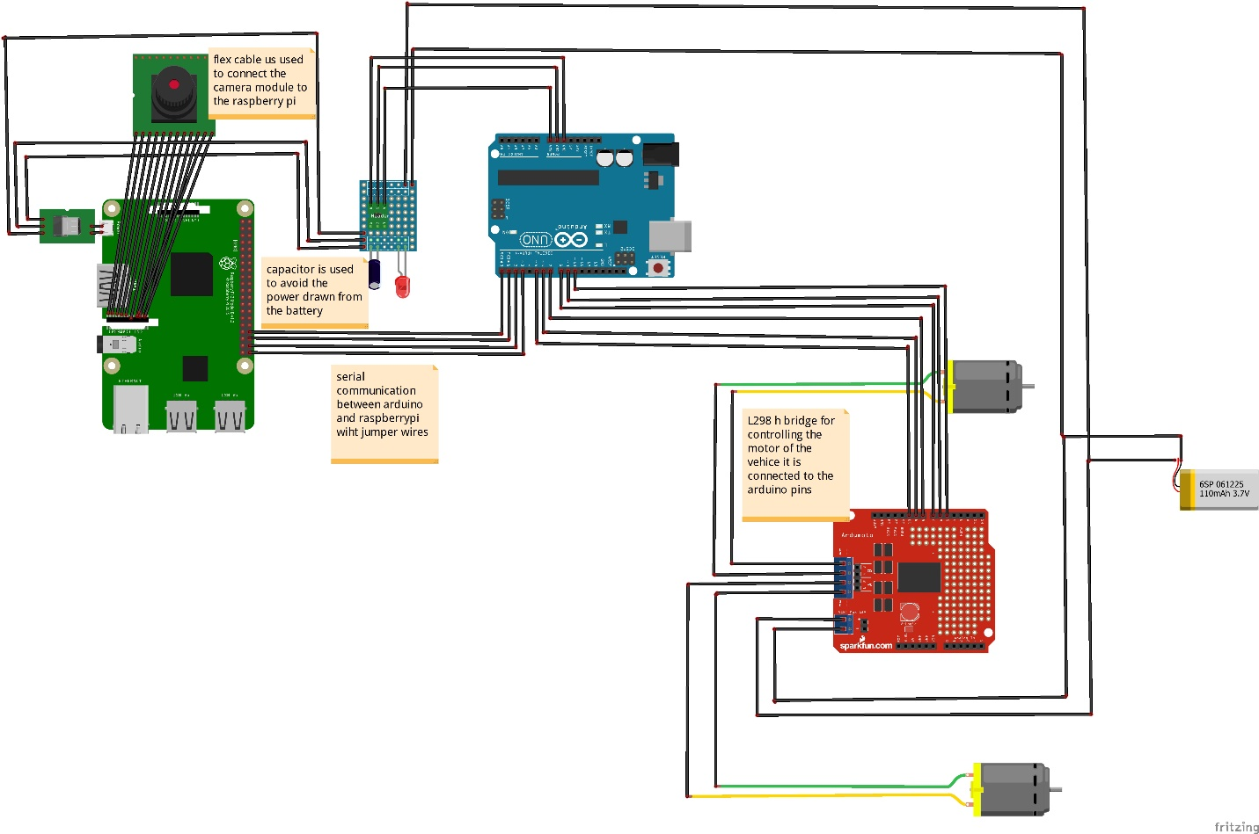

**Arduino:**

This microcontroller is based on ATmega329P.There are 14 digital input/output pins available out of which 6 can be used a PWM outputs. It also supports 6 analog inputs. It has 16 MHz quartz crystal, a USB connection,a power jack, an ICSP header and a reset button. It has 32 kb of flash memory and 2 kb of SRAM and weighs around 25g .Apart from all these features Arduino IDE is very user friendly and uses basic c as its programming language. After attaching these hardware on the car and connecting Arduino with the controller.

**Raspberry Pi:**

The Raspberry Pi is a small low cost single board computer having a processor speed ranging from 700 MHz to 1.2 GHz for the Pi 3.The on-board memory ranges from 256 MB to 1 GB RAM. The boards supports up to 4 USB ports along with HDMI port. Along from all this it has number of GPIO pins which support protocols like I²C.Moreover it also supports Wi-Fi and Bluetooth facility which makes device very compatible with other devices. It supports Scratch and Python programming languages . It supports manym operating systems like Ubuntu MATE, Snappy Ubuntu, Pidora, Linutop and many more out of which Raspbian is specifically designed to support Raspberry Pi’s hardware

**Pi camera:**

Pi camera is great gadget to capture time-lapse, slow motion with great video clarity. The dimensions of camera are 25mmto 24mm by 9mm, which connects to Raspberry Pi via a flexible elastic cord which supports serial interface. The camera image sensor has a resolution of five megapixels and has a focused lens. The camera provides a great support for security purpose. Various characteristics of the camera are it supports 5MP sensor, Wide image, capable of 2592x1944 stills, 1080p30 video on Camera module v1

**L2998 bridge motor controller:**

The L298 is an integrated monolithic circuit in a 15- lead Multiwatt and PowerSO20 packages. It is a high voltage, high current dual full-bridge driver designed to accept standard TTL logic levels and drive inductive loads such as relays, solenoids, DC and stepping motors. Two enable inputs are provided to enable or disable the device independently of the input signals. The emitters of the lower transistors of each bridge are connected together and the corresponding external terminal can be used for the connection of an external sensing resistor. An additional supply input is provided so that the logic works at a lower voltage.

**Python:**

It is the programming language used for Machine Learning or Artificial Intelligence tasks.

**OpenCV:**

It is a powerful computer vision package. It can be trained to detect objects in images (or video).

**Tensorflow:**

It i**s** Google’s popular deep learning framework. Tensorflow is used to make smart decisions based on the neural network.

**Google Colab:**

Colab is a free cloud-based Jupyter Notebooks that let you write and train deep learning models in Python. The popular python libraries supported are TensorFlow, Keras, OpenCV, and Pandas

**OpenCV for Computer Vision:**

Perception Sensor of our PiCar is a USB DashCam. A DashCam gives us a live video, which is essentially a sequence of pictures. We will use OpenCV, a powerful open source computer vision library, to capture and transform these pictures

**Numpy** and **Matplotlib** are two very useful python modules that we will use in conjunction with OpenCV for image processing and rendering.

**Tensorflow For CPU:**

Raspberry Pi is not recommended to perform any deep learning (i.e. model training), as its CPU is vastly insufficient for backward propagation, a very slow operation required in the learning process. However, we can use the **Tensorflow CPU** to do model prediction based on a pre-trained model. Model Training which uses only forward propagation, a much faster computer operation.

**TensorFlow for Edge TPU Co-Processor:**

Inferences can only do so on a relatively shallow model (say 20–30 layers) in real time.  But for deeper models (100+ layers), we would need the Edge TPU. A live video screen coming up, and it will try to identify objects in the screen at around 7–8 Frames/sec**.**[**COCO (Common Object in COntext) object detection model**](http://cocodataset.org/#home) can detect about 100 common objects, like a person etc.

The object detection model used in this program is called [**ssd_mobilenet_coco_v2**](https://github.com/tensorflow/models/blob/master/research/object_detection/g3doc/detection_model_zoo.md#coco-trained-models)

**Autonomous Lane Navigation via OpenCV:**

 Adaptive Cruise Control (ACC) and some forms of Lane Keep Assist System (LKAS). Adaptive cruise control uses radar to detect and keep a safe distance with the car in front of it. Lane Keep Assist System is a relatively new feature, which uses a windshield mount camera to detect lane lines, and steers so that the car is in the middle of the lane. Lane detection concept will turn a video of the road into the coordinates of the detected lane lines. This will be achieved via the computer vision package: OpenCV.

The color space used in the image is  RGB (Red/Green/Blue). The RGB will be converted into HSV (Hue/Saturation/Value) color space.

**Detecting Edges of Lane Lines**:

The [**Canny edge detection function**](https://docs.opencv.org/master/da/d22/tutorial_py_canny.html)is a powerful command that detects edges in an image. This function is available in OpenCV. It converts the detected lane lines into number of white pixels

**Detecting Line Segments:**

The extraction of the coordinates of these lane lines from these white pixels. OpenCV contains a magical function, called Hough Transform, which does exactly this. Hough Transform is a technique used in image processing to extract features like lines, circles, and ellipses. We will use it to find straight lines from a bunch of pixels that seem to form a line. The function HoughLinesP essentially tries to fit many lines through all the white pixels and return the most likely set of lines, subject to certain minimum threshold constraints. Internally, HoughLineP detects lines using Polar Coordinates. Polar Coordinates uses elevation angle( as camera is at elevated height) and distance from the origin (car).

**Steering**: A heading Line is generated using two detected lane lines. A steering angle is calculated using the heading line .

**Image Augmentation:**

Some of the common augmentation operations are zooming, panning, changing exposure values, blurring, and imaging flipping. By randomly applying any or all of these 5 operations on the original images, we can generate a lot more training data. Our final trained model becomes much more robust.

**The Nvidia Model:**

The inputs to the Nvidia model are video images from DashCams onboard the car, and outputs are the steering angle of the car. The model uses the video images, exacts information from them, and tries to predict the car’s steering angles. At the core of the NVidia model, there is a **Convolutional Neural Network.** CNNs are used prevalently in image recognition deep learning models. The intuition is that CNN is especially good at extracting visual features from images from its various layers. The CNN layers used in the Nvidia model is very similar as above, as it extracts lines and edges in its early layers and complex shapes in its later layers.

Our Deep Learning model will apply CNNs, Transfer Learning , RNNs too.

Transfer Learning is used to apply the correct decision and observations observed in previous situations to current situation being faced which is similar to previous observation observed.

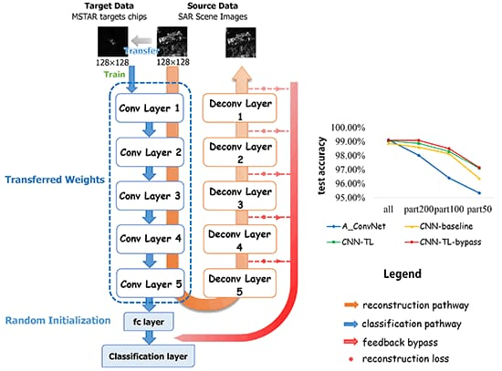

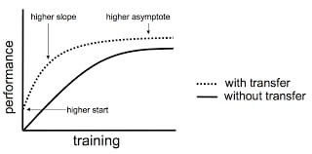

**Traffic Sign and Pedestrian Detection and Handling:**

Usage of Transfer Learning to Adapt a Pretrained MobileNet SSD Deep Learning Model to Detect Traffic Signs and Pedestrians with Google’s Edge TPU.

**Object Detection:** Object detection is a well-known problem in computer vision and deep learning. There are two components in an object detection model, namely, **base neural network** and **detection neural network**. [**Base neutral networks**](https://en.wikipedia.org/wiki/Convolutional_neural_network)are CNNs that extract features from an image, from low-level features, such as lines, edges, or circles to higher-level features, such as a face, a person, a traffic light, or a stop sign. Well-known base neural networks are LeNet, InceptionNet(aka. GoogleNet), ResNet, VGG-Net, AlexNet, and MobileNet, etc. We will be using Mobile Net

**Detection Neural Networks**:

The [**detection neural networks**](https://en.wikipedia.org/wiki/Object_detection) are attached to the end of a base neural network and used to simultaneously identify multiple objects from a single image with the help of the extracted features. Some of the popular detection networks are SSD (Single Shot MultiBox Detector), R-CNN (Region with CNN features), Faster R-CNN, and YOLO. We will be using SSD.

**Image Collection and Labeling:**

6 object types, namely, Red Light, Green Light, Stop Sign, 40 Mph Speed Limit, 25 Mph Speed Limit, and a few Lego figurines as pedestrians. A free tool, called[**labelImg**](https://tzutalin.github.io/labelImg/) will be used to label the 6 types of objects which will be later used to detect and predict.

Transfer Learning will be used to detect Traffic signals and predict the action.

**Planning and Motion Control**: There are 2 approaches 1) rule based 2)end to end approach.

We will be using a combination of rule based and end to end approach. In end to end approach, input lot of good driving video footages will be given, through Transfer Learning and RNNs and CNNs , it will learn the behaviour of driving car when various environments are encountered. It will later apply all learnt behaviour in the current situation.It will try to mimick driving behaviour.

Rule based approach will be stating action or decision (forcefully) to be taken when certain traffic signals are encountered.

**Benefits for the Environment:**

* Without the need for a driver, cars could become mini leisure rooms. Without the need for controls, there would be more space available inside the vehicle and no need for passengers to face forwards.
* Entertainment technology, such as video screens, could be used without any concern of distracting the driver.
* Human drivers notoriously bend rules and take risks, but driverless cars will obey every road rule and posted speed limit.
* Over 80% of car crashes in the US are caused by driver error. There would be less user errors and fewer mistakes on the roads if all vehicles became driverless. Drunk and drugged drivers would also be a thing of the past, and passengers might even sleep without risking safety.
* Travelers would be able to journey overnight and sleep for the duration.
* Traffic could be coordinated more smoothly in urban areas to prevent bottlenecks and traffic jams at busy times. Commute times could be reduced drastically.
* Driving fatigue and getting lost would be things of the past.
* Sensory technology could potentially perceive the environment better than humans could, seeing farther ahead, better in poor visibility, and detecting smaller and more subtle obstacles. Plus, several cameras might be used at once, and cameras have no blind spots, so they will be more aware and vigilant than a human driver ever could be.
* Speed limits could be safely increased, thereby shortening journey times.
* Difficult maneuvering and parking would be less stressful and require no special skills. The car could even just drop you off and then go park itself.
* People who have difficulties driving—such as disabled people, older citizens, and children—would be able to experience the freedom of solo car travel.
* There would be no need for drivers licenses or driving tests.
* Presumably, with fewer associated risks, insurance premiums for car owners would go down.
* Efficient travel also means fuel savings, simultaneously cutting costs and making less of a negative environmental impact.
* Greater efficiency would mean fewer emissions and less pollution from cars in general.
* Reduced need for safety gaps, lanes, and shoulders means that road capacities for vehicles would be significantly increased.
* Passengers should experience a smoother riding experience.
* Self-aware cars would lead to a reduction in car theft.

**Applications of Self Driving Car:**

**Computer Vision:**

Waymo is a US-based company that offers namesake autonomous vehicles, which they claim can help auto manufacturers and ride-hailing businesses make the roads safer for both pedestrians and motorists using a combination of computer vision, audio recognition, and machine learning technologies. Waymo claims users can experience a safer driving experience through the AV’s vision system, which is capable of object and event detection and response. The vision system’s cameras constantly scan the road for moving and static objects, such as pedestrians, cyclists, other vehicles, traffic lights, construction cones, and other road features it passes along the road through a 360-degree view of its surroundings.

**General Motors:**

By 2019, General Motors aims to offer ride-sharing services with perception software, which they claim can help operate self-driving cars safely in busy urban environments using a multisensor vision system. General Motors claims the system can safely navigate city streets with a 360-degree view of the world. The system is fitted with five light detection and ranging (LiDARs) sensors, 16 cameras, and 21 radars. Using laser light, the LiDAR measures the distance of both fixed and moving objects from the vehicle. The radars complement LiDAR in that they are able to perceive solid objects in low light conditions. Long-range sensors track speeding objects, such as oncoming vehicles, while the short-range sensors provide detail about moving objects near the AVs pedestrians and bicycles.

**Quanergy Systems**

Quanergy Systems is a Silicon Valley-based company with about 200 employees. The company offers a software called Qortex for Transportation, which they claim can help autonomous vehicle manufacturers increase car safety using computer vision technology. Quanergy claims that the application detects objects based on imaging data captured by the system’s LiDAR sensors. This data could include 3D images of people on the streets, other vehicles, buildings, animals, trees, and signs on the road. The underlying algorithms then measure the distance of the objects from the vehicle, as well as identify and classify them. Once an object is classified, the system triggers an action based on the real-time scenario.

**Virtual Simulations**

Microsoft offers a software called AirSim, which they claim can help autonomous vehicle manufacturers test vehicle safety of and train their machine learning algorithms using deep learning, computer vision, and reinforcement learning for autonomous vehicles. The company states that, in offering this open-source application for testing algorithms, it aims to make the development of self-driving cars available to more companies. Initially developed as a tool for game development, the new version of AirSim includes car simulations, new environments, and a programming interface that allows developers to run their algorithms.

**Benefits for the Society:**

1. **Safety**

The overwhelming benefit is safety. **Over 1.3 million people are killed annually on the roads** around the world with several million seriously injured. **Most of these accidents (over 90%) are caused by human error**. According to the US National Highway Traffic Safety Administration [4], alcohol abuse, speeding, and driver distraction, are the cause of the vast majority of these accidents. But autonomous vehicles will never be susceptible to any of these failings. It has been estimated that **driverless cars will save over a million lives each year**. Improved driving safety has other implications because car accident injuries take disproportionate healthcare resources. Reducing these accidents could result in massive savings and better use of healthcare facilities in other areas of medical care. Furthermore, because of the fewer number of accidents, the construction of autonomous cars could use some less dense materials like fiber glass, and lead to more efficient travel. Improved safety is a big incentive for car manufacturers because they will gain more confidence from the travelling public.

1. **Convenience**

Whilst driving is a pleasurable activity for many people, having to spend many hours commuting daily or undertaking long trips can become a chore. A passenger can spend time doing other things in a driverless car. There will also be fewer of them on the roads. Therefore, **less time will be spent in traffic jams**. They will all be connected on-line, meaning that they can communicate with each other and coordinate intentions. All this combined should make for a more pleasant and less stressful passenger experience.

1. **Reclaiming our streets**

Cars take up large amounts of space in our urbanized areas. In the long-term however, **autonomous cars are likely to substantially reduce the number of cars in use**. This means that the vast areas of land, hitherto used for car parking will become available. At present, individuals that buy cars have sole use. This means that they spend about 97% of their time, on average, unused – in garages, car parks, or roads. This is likely to change because the users of autonomous cars in the future would probably be offered access rather than being sold ownership. This type of usage is becoming common nowadays with music and video film users. For example, subscribing to streaming services like Spotify, rather than buying vinyl records or CDs, reduces the requirement for physical storage. In the same way, it is likely that **owning a car will become less common**. Ownership may not be important as long as the service is provided. According to the think tank RethinkX [5], autonomous cars will be fleet owned, possibly by the car manufacturers. Furthermore, they predict that by 2030 **there will be an 80% drop in demand for new cars**. They say this because there is likely to be at least a 10 times increase in utilization of autonomous cars. This increase in utilization means that far fewer will be needed on our roads

1. **A Cleaner Environment**

Driverless cars will use electric power because **they will be harder to operate with fossil fuels**. There would be many jobs created from the new technology in developing the new infrastructure required to charge electric batteries, and so on. This would also mean a move away from fossil fuel transport to a less polluting form of energy with fewer carbon emissions – reducing the effect on global warming.